♥♥♥♥♥♥♥♥♥♥♥♥♥♥♥♥♥♥♥♥♥♥♥♥♥♥♥♥♥♥♥♥♥♥♥♥♥♥♥♥♥♥♥♥

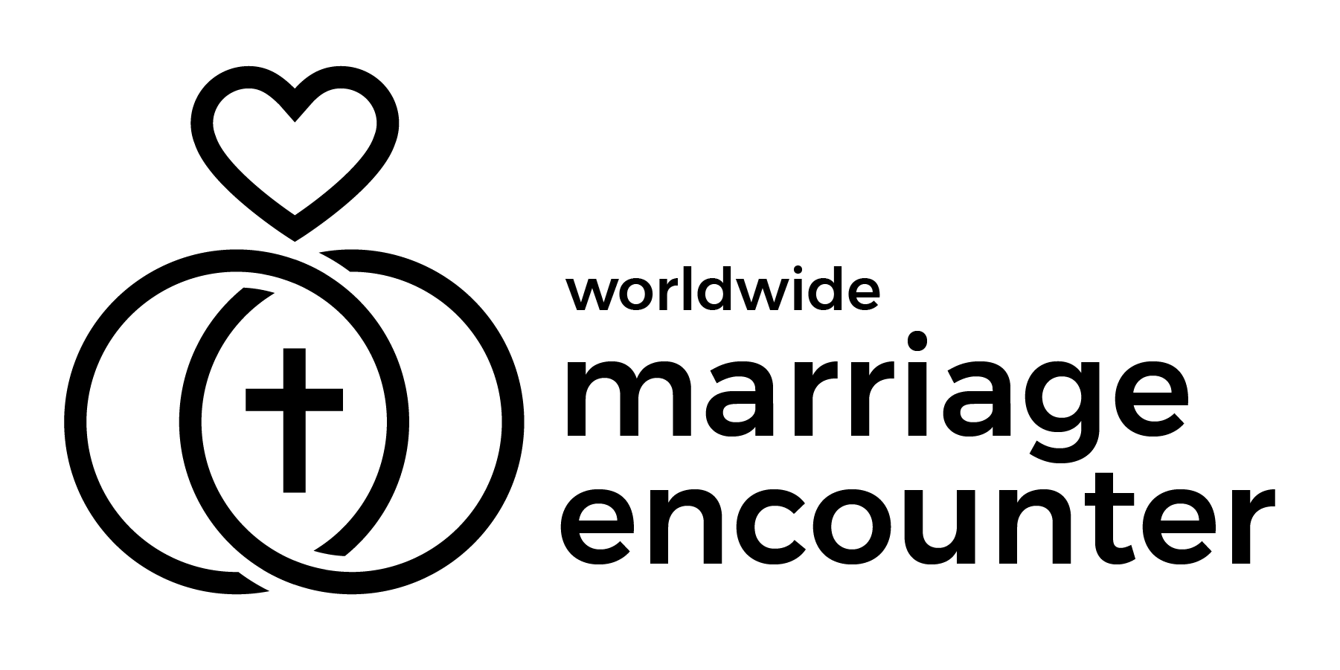 Worldwide Marriage Encounter
Dallas - Fort Worth - East Texas
♥♥♥♥♥♥♥♥♥♥♥♥♥♥♥♥♥♥♥♥♥♥♥♥♥♥♥♥♥♥♥♥♥♥♥♥♥♥♥♥♥♥♥♥
Bulletin Announcements: (please include these announcements in your parish bulletins)
Feb. 28 - March 1, 2026 - "Rise, and do not be afraid." Let us not be afraid to live out our Sacrament of Marriage to the fullest. Strengthen, renew, and rekindle your marriage sacrament by attending the next Worldwide Marriage Encounter Experience. The next Worldwide Marriage Encounter Experience is Apr. 10-12, 2026. To apply go to www.wwme.org. Para mas informacion de Encuentro Matrimonial en Espanol, escriba a mdgallegos06@gmail.com 214-497-0188.
March 7-8, 2026 - “Everyone who drinks this water will be thirsty again; but whoever drinks the water I shall give will never thirst.” Let Jesus fill your thirst for a blessed marriage. Participate in the next Worldwide Marriage Encounter Experience. The next Worldwide Marriage Encounter Experience is Apr. 10-12, 2026. To apply go to www.wwme.org. Para mas informacion de Encuentro Matrimonial en Espanol, escriba a mdgallegos06@gmail.com 214-497-0188.
March 14-15, 2026 - “The Lord is my shepherd; there is nothing I shall Want.” Let the Lord be the shepherd of your marriage. Attend a Worldwide Marriage Encounter Experience. The next Worldwide Marriage Encounter Experience is Apr. 10-12, 2026. To apply go to www.wwme.org. Para mas informacion de Encuentro Matrimonial en Espanol, escriba a mdgallegos06@gmail.com 214-497-0188.
March 21-22, 2026 - “I am the resurrection and the life; whoever believes in me, even if he dies, will live, and everyone who lives and believes in me will never die.” Do you believe that Jesus is the Lord of your marriage? Bring God into your marriage by attending a Worldwide Marriage Encounter Experience. The next Worldwide Marriage Encounter Experiences are Apr. 10-12 and July 17-19, 2026. To apply go to www.wwme.org. Para mas informacion de Encuentro Matrimonial en Espanol, escriba a mdgallegos06@gmail.com 214-497-0188.
March 28-29, 2026 - “The Lord, God is my help.” Let God help your marriage to be the Sacrament He intended. Strengthen, renew, and rekindle your marriage sacrament by attending an upcoming Worldwide Marriage Encounter Experience. The next Worldwide Marriage Encounter Experiences are Apr. 10-12 and July 17-19, 2026. To apply go to www.wwme.org. Para mas informacion de Encuentro Matrimonial en Espanol, escriba a mdgallegos06@gmail.com 214-497-0188.
Ken & Cathy Gelzleichter – ken_cathy_101577@verizon.net or (972) 219-9027
♥♥♥♥♥♥♥♥♥♥♥♥♥♥♥♥♥♥♥♥♥♥♥♥♥♥♥♥♥♥♥♥♥♥♥♥♥♥♥♥♥♥♥♥
♥♥♥♥♥♥♥♥♥♥♥♥♥♥♥♥♥♥♥♥♥♥♥♥♥♥♥♥♥♥♥♥♥♥♥♥♥♥♥♥♥♥♥♥

Worldwide Marriage Encounter
Dallas - Fort Worth - East Texas
♥♥♥♥♥♥♥♥♥♥♥♥♥♥♥♥♥♥♥♥♥♥♥♥♥♥♥♥♥♥♥♥♥♥♥♥♥♥♥♥♥♥♥♥
Bulletin Announcements: (please include these announcements in your parish bulletins)

Febrero 28-Marzo 1, 2026 - "Levántate y no tengas miedo" . No tengamos miedo de vivir al máximo nuestro sacramento de matrimonio. Refuerza, renueva y reaviva tu Sacramento de matrimonio al asistir a la próxima Experiencia del Encuentro Matrimonial Mundial. Para mas informacion de Encuentro Matrimonial en Espanol, escriba a mdgallegos06@gmail.com 214-497-0188.

Marzo 7-8, 2026 - "Todos los que beben de esta agua volveran a tener sed, pero el que bebe del agua que Yo le dare nunca mas tendrá sed". Deja que Jesus satisfaga tu sed para tener un matrimonio bendito. Participa en la próxima Experiencia del Encuentro Matrimonial Mundial. Para mas informacion de Encuentro Matrimonial en Espanol, escriba a mdgallegos06@gmail.com 214-497-0188.

Marzo 14-15, 2026 - "El Señor es mi Pastor no hay nada que yo quiera". Deja que el Señor sea al Pastor de tu matrimonio. Asiste a una Experiencia del Encuentro Matrimonial Mundial. Para mas informacion de Encuentro Matrimonial en Espanol, escriba a mdgallegos06@gmail.com 214-497-0188.

Marzo 21-22, 2026 - "Yo soy la Resurrección y la vida; todo el que crea en mi, aunque muera vivirá, y todos los que vivan y crean en mi no morirán. Crees que Jesus es el Señor de tu matrimonio? Trae a Dios a tu matrimonio asistiendo a una Experiencia del Encuentro Matrimonial Mundial. Para mas informacion de Encuentro Matrimonial en Espanol, escriba a mdgallegos06@gmail.com 214-497-0188.

Marzo 28-29, 2026-" El Señor Dios es mi ayuda" Deja que Dios ayude a que tu matrimonio sea el Sacramento que El quiere. Refuerza, renueava y reaviva tu sacramento de matrimonio al asistir a una Experiencia del Encuentro Matrimonial Mundial. Para mas informacion de Encuentro Matrimonial en Espanol, escriba a mdgallegos06@gmail.com 214-497-0188.

Ken & Cathy Gelzleichter – ken_cathy_101577@verizon.net or (972) 219-9027
♥♥♥♥♥♥♥♥♥♥♥♥♥♥♥♥♥♥♥♥♥♥♥♥♥♥♥♥♥♥♥♥♥♥♥♥♥♥♥♥♥♥♥

