♥♥♥♥♥♥♥♥♥♥♥♥♥♥♥♥♥♥♥♥♥♥♥♥♥♥♥♥♥♥♥♥♥♥♥♥♥♥♥♥♥♥♥♥

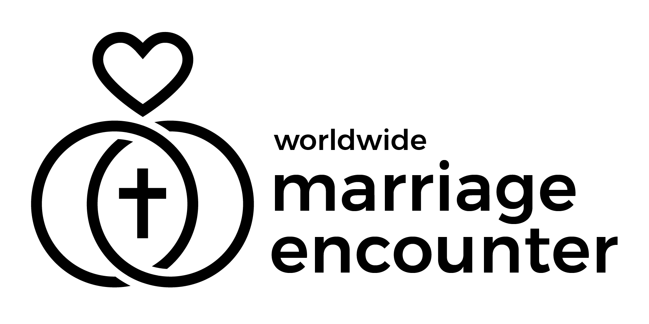 Worldwide Marriage Encounter
Dallas - Fort Worth - East Texas
♥♥♥♥♥♥♥♥♥♥♥♥♥♥♥♥♥♥♥♥♥♥♥♥♥♥♥♥♥♥♥♥♥♥♥♥♥♥♥♥♥♥♥♥
Bulletin Announcements: (please include these announcements in your parish bulletins)
July 4-5, 2026 - "Come to me, all you who labor and are burdened, and I will give you rest.” Give your marriage a rest from the world and renew your love by participating in a Worldwide Marriage Encounter Experience. The next Worldwide Marriage Encounter experiences are July 17-19 and Oct. 9-11, 2026. To apply go to www.wwme.org. Questions – email apply@dfwme.org or call 469-444-0904. Para mas informacion de Encuentro Matrimonial en Espanol, escriba a mdgallegos06@gmail.com 214-497-0188.
July 11-12, 2026 - “But some seed fell on rich soil and produced fruit, a hundred or sixty or thirtyfold.” Help your marriage be like the rich soil by taking part in a Worldwide Marriage Encounter Experience. The next Worldwide Marriage Encounter experiences are July 17-19 and Oct. 9-11, 2026. To apply go to www.wwme.org. Questions – email apply@dfwme.org or call 469-444-0904. Para mas informacion de Encuentro Matrimonial en Espanol, escriba a mdgallegos06@gmail.com 214-497-0188.
July 18-19, 2026 - Just as a small mustard seed can become a large and elaborate bush, discover how a Worldwide Marriage Encounter Weekend can encourage our marriage to blossom and provide a lifetime of joy. Attend a Worldwide Marriage Encounter Experience. The next Worldwide Marriage Encounter experience is Oct. 9-11, 2026. To apply go to www.wwme.org. Questions – email apply@dfwme.org or call 469-444-0904. Para mas informacion de Encuentro Matrimonial en Espanol, escriba a mdgallegos06@gmail.com 214-497-0188.
July 25-26, 2026 - "The kingdom of heaven is like a treasure buried in a field, which a person finds and hides again, and out of joy goes and sells all that he has and buys that field. Find the buried treasures in your marriage by participating in a Worldwide Marriage Encounter Experience. The next Worldwide Marriage Encounter experience is Oct. 9-11, 2026. To apply go to www.wwme.org. Questions – email apply@dfwme.org or call 469-444-0904. Para mas informacion de Encuentro Matrimonial en Espanol, escriba a mdgallegos06@gmail.com 214-497-0188.
Ken & Cathy Gelzleichter – ken_cathy_101577@verizon.net or (972) 219-9027
♥♥♥♥♥♥♥♥♥♥♥♥♥♥♥♥♥♥♥♥♥♥♥♥♥♥♥♥♥♥♥♥♥♥♥♥♥♥♥♥♥♥♥♥

Would you like to have someone from Worldwide Marriage Encounter speak to your parish? Let us know and we will arrange it.
♥♥♥♥♥♥♥♥♥♥♥♥♥♥♥♥♥♥♥♥♥♥♥♥♥♥♥♥♥♥♥♥♥♥♥♥♥♥♥♥♥♥♥♥

Worldwide Marriage Encounter
Dallas - Fort Worth - East Texas
♥♥♥♥♥♥♥♥♥♥♥♥♥♥♥♥♥♥♥♥♥♥♥♥♥♥♥♥♥♥♥♥♥♥♥♥♥♥♥♥♥♥♥♥
Bulletin Announcements: (please include these announcements in your parish bulletins)

Julio 4-5, 2026 - "Vengan a mi todos los que laboran y estan angustiados, y yo les dare descanso". Dale a tu matrimonio descanso del mundo y renueva tu amor al participar en una Experiencia del Encuentro Matrimonial Mundial. Para mas informacion de Encuentro Matrimonial en Espanol, escriba a mdgallegos06@gmail.com 214-497-0188.

Julio 11-12, 2026 - “Pero parte de la semilla cayó en tierra rica y produjo cien, o sesenta, o treinta por ciento de fruta”. Ayuda que tu matrimonio sea como la tierra rica al tomar parte en una Experiencia del Encuentro Matrimonial Mundial. Para mas informacion de Encuentro Matrimonial en Espanol, escriba a mdgallegos06@gmail.com 214-497-0188.

Julio 11-12, 2026 - "Pero parte de la semilla cayo en tierra rica y produjo cien o sesenta o treinta por ciento de fruta". Ayuda que tu matrimonio sea como lJulio 18-19, 2026 - De la misma manera que una pequeña semilla de mostaza se puede convertir en un arbusto grande y elaborado descubre como un fin de semana de una Experiencia del Encuentro Matrimonial Mundial puede ayudar a que nuestro matrimonio florezca y nos de un vida llena de alegria. Asiste a una Experiencia del Encuentro Matrimonial Mundial. Para mas informacion de Encuentro Matrimonial en Espanol, escriba a mdgallegos06@gmail.com 214-497-0188.

Julio 25-26, 2026 -"El Reino del cielo es como un tesoro enterrado en un campo, donde una persona lo encuentra y lo vuelve a enterrar y llena de alegria vende todo lo que tiene y compra ese campo. Encuentra los tesoros en tu matrimonio al participar en una Experiencia del Encuentro Matrimonial Mundial. del Encuentro Matrimonial Mundial. Para mas informacion de Encuentro Matrimonial en Espanol, escriba a mdgallegos06@gmail.com 214-497-0188.

Ken & Cathy Gelzleichter – ken_cathy_101577@verizon.net or (972) 219-9027
♥♥♥♥♥♥♥♥♥♥♥♥♥♥♥♥♥♥♥♥♥♥♥♥♥♥♥♥♥♥♥♥♥♥♥♥♥♥♥♥♥♥♥

