♥♥♥♥♥♥♥♥♥♥♥♥♥♥♥♥♥♥♥♥♥♥♥♥♥♥♥♥♥♥♥♥♥♥♥♥♥♥♥♥♥♥♥♥

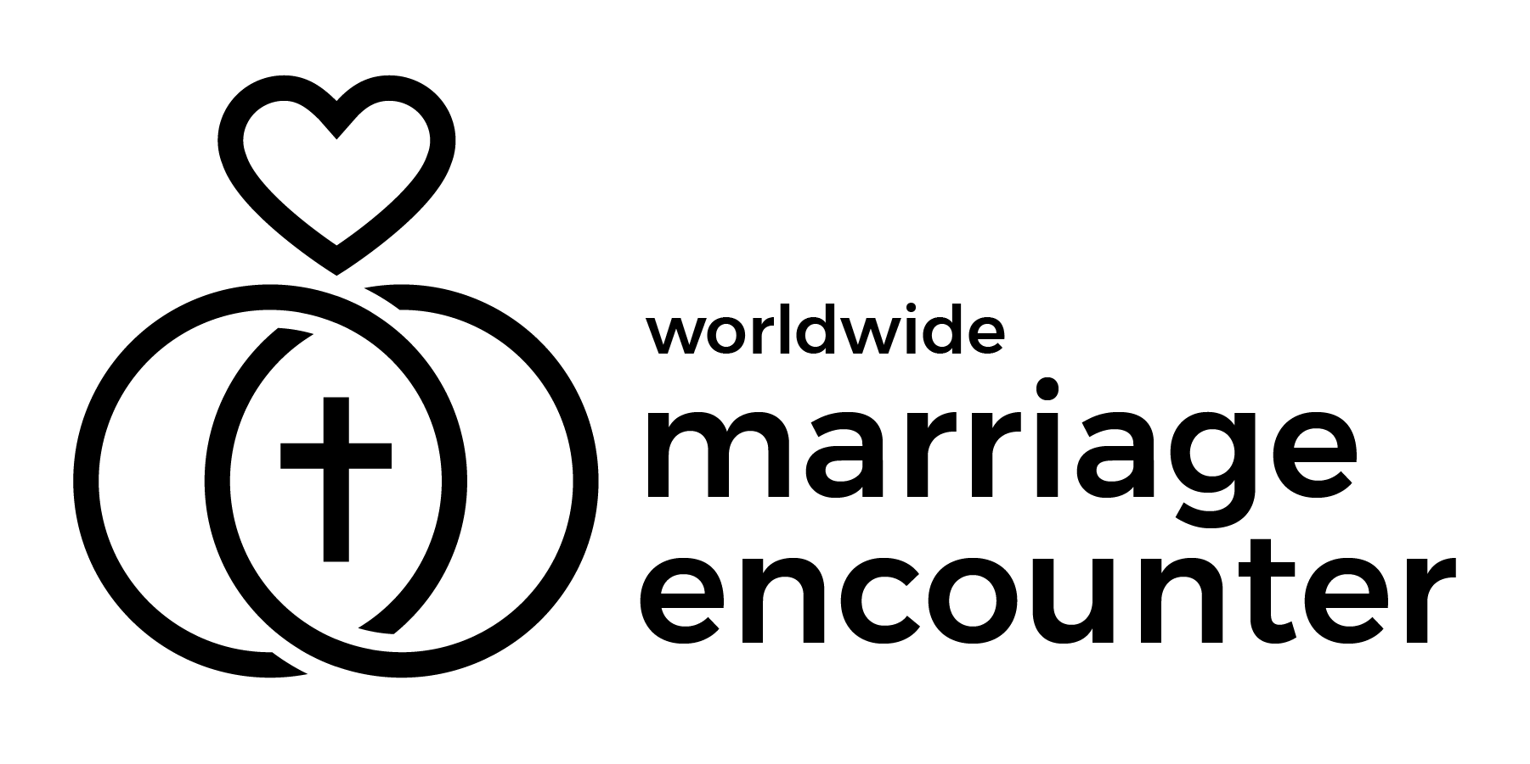 Worldwide Marriage Encounter
Dallas - Fort Worth - East Texas
♥♥♥♥♥♥♥♥♥♥♥♥♥♥♥♥♥♥♥♥♥♥♥♥♥♥♥♥♥♥♥♥♥♥♥♥♥♥♥♥♥♥♥♥
Bulletin Announcements: (please include these announcements in your parish bulletins)

April 4-5, 2026 - Happy Easter! He has risen! Let us welcome Jesus even more into our marriages by participating in a Worldwide Marriage Encounter Experience. The next Worldwide Marriage Encounter experiences are Apr. 10-12 and July 17-19, 2026. To apply go to www.wwme.org. Questions – email apply@dfwme.org or call 469-444-0904. Para mas informacion de Encuentro Matrimonial en Espanol, escriba a mdgallegos06@gmail.com 214-497-0188.
April 11-12, 2026 - Jesus came and stood in their midst and said to them, “Peace be with you.” Bring the peace of Christ into your marriage by taking part in a Worldwide Marriage Encounter Experience. The next Worldwide Marriage Encounter experience is July 17-19, 2026. To apply go to www.wwme.org. Questions – email apply@dfwme.org or call 469-444-0904. Para mas informacion de Encuentro Matrimonial en Espanol, escriba a mdgallegos06@gmail.com 214-497-0188.
April 18-19, 2026 - “Were not our hearts burning within us while he spoke to us on the way and opened the Scriptures to us?” Let your hearts burn for Jesus and your spouse. Learn how on the upcoming Worldwide Marriage Encounter Experiences. The next Worldwide Marriage Encounter experience is July 17-19, 2026. To apply go to www.wwme.org. Questions – email apply@dfwme.org or call 469-444-0904. Para mas informacion de Encuentro Matrimonial en Espanol, escriba a mdgallegos06@gmail.com 214-497-0188.
April 25-26, 2026 - “…I came so that they might have life and have it more abundantly." Live your married lives “more abundantly” by participating in a Worldwide Marriage Encounter Experience. The next Worldwide Marriage Encounter experience is July 17-19, 2026. To apply go to www.wwme.org. Questions – email apply@dfwme.org or call 469-444-0904. Para mas informacion de Encuentro Matrimonial en Espanol, escriba a mdgallegos06@gmail.com 214-497-0188.
Ken & Cathy Gelzleichter – ken_cathy_101577@verizon.net or (972) 219-9027
♥♥♥♥♥♥♥♥♥♥♥♥♥♥♥♥♥♥♥♥♥♥♥♥♥♥♥♥♥♥♥♥♥♥♥♥♥♥♥♥♥♥♥♥
♥♥♥♥♥♥♥♥♥♥♥♥♥♥♥♥♥♥♥♥♥♥♥♥♥♥♥♥♥♥♥♥♥♥♥♥♥♥♥♥♥♥♥♥

Worldwide Marriage Encounter
Dallas - Fort Worth - East Texas
♥♥♥♥♥♥♥♥♥♥♥♥♥♥♥♥♥♥♥♥♥♥♥♥♥♥♥♥♥♥♥♥♥♥♥♥♥♥♥♥♥♥♥♥
Bulletin Announcements: (please include these announcements in your parish bulletins)

Abril 4-5, 2026 - !Feliz Pascua! El ha resucitado! Recibamos mejor a Jesus en nuestros matrimonios al participar en una Experiencia del Encuentro matrimonial Mundial. Para mas informacion de Encuentro Matrimonial en Espanol, escriba a mdgallegos06@gmail.com 214-497-0188.

Abril 11-12, 2026 - Jesus se apareció y estuvo entre ellos y les dijo "La paz este con ustedes". Trae la paz de Cristo a tu matrimonio tomando parte en una Experiencia del Encuentro matrimonial Mundial. Para mas informacion de Encuentro Matrimonial en Espanol, escriba a mdgallegos06@gmail.com 214-497-0188.

Abril 18-19, 2026 - "No estaban nuestros corazones ardiendo mientras nos hablaba en el camino y nos explicaba las Escrituras?". Deja que tus corazones ardan por Jesus y tu esposo/a. Aprende como en la Próxima Experiencia de Encuentro matrimonial Mundial. Para mas informacion de Encuentro Matrimonial en Espanol, escriba a mdgallegos06@gmail.com 214-497-0188.

Abril 25-26, 2026 - " Vine para que ellos tuvieran vida y la tuvieran en abundancia." Vivan su vida de casados "mas abundanamente" participando en una Experiencia del Encuentro matrimonial Mundial. Para mas informacion de Encuentro Matrimonial en Espanol, escriba a mdgallegos06@gmail.com 214-497-0188.

Ken & Cathy Gelzleichter – ken_cathy_101577@verizon.net or (972) 219-9027
♥♥♥♥♥♥♥♥♥♥♥♥♥♥♥♥♥♥♥♥♥♥♥♥♥♥♥♥♥♥♥♥♥♥♥♥♥♥♥♥♥♥♥

