Catholic Relief Services (CRS) Special Collection
March 14-15, 2026
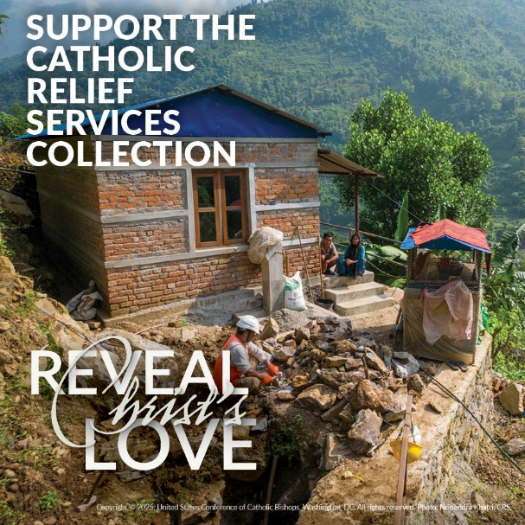
The Catholic Relief Services Collection is an
opportunity to improve the lives of the most vulnerable people around the world and here in the United States. Your support funds organizations that aid travelers, people affected by war and natural disasters, others whose work or unique cultural circumstances require special pastoral support, and migrants and refugees displaced by conflict, persecution, or political instability. Most Reverend Michael Olson has asked that Catholics in the Diocese of Fort Worth join him in responding to these needs through a special collection for Catholic Relief Services (CRS) in all parishes on March 14-15.

The Collection supports six Catholic agencies that prioritize the family and protect the life and dignity of each person:
In the United States
- Welcoming suffering refugees through USCCB Migration and Refugee Services (MRS)
- Legal aid to struggling immigrants through Catholic Legal Immigration Network, Inc. (CLINIC)
- Ministry to people on the margins through the pastoral work of the USCCB Secretariat of Cultural Diversity in the Church
Around the World
- For hungry mothers and children in Nepal and elsewhere through the humanitarian work of Catholic Relief Services (CRS), the official overseas relief agency of the bishops of the United States.
- Working for peace through the public policy and education and communication work of the USCCB Secretariat of Justice and Peace.
- For the victims of natural disaster through the Holy Father’s Relief Fund.
To learn more about the work of Catholic Relief Services and the people who benefit, please visit https://www.usccb.org/national-collection/catholic-relief-services-collection.

General Information for Parish Business Managers
Collection Date | March 14-15, 2026
Date Funds Due to Diocese | April 6, 2026
Intacct Account Number | 214000
Intacct Fund Number | 28008
Give Online | https://bit.ly/DioceseSpecialCollections (case sensitive)


Promotional Information
Four practical ways you can support The Catholic Relief Services Collection are to mention it at Mass, tell this story, use the parish appeal or bulletin announcements inside, and use the additional resources, including web ads and a social media tool kit, available at www.usccb.org/catholic-relief/collection

Please use your bulletin, pulpit announcements, website and social media to promote this special collection. You may use the English and Spanish ads provided or use the following suggested promotional copy:

Información Promocional
Cuatro formas prácticas de apoyar la Colecta de Catholic Relief Services son mencionarlo en misa, contar esta historia, utilizar el llamamiento parroquial o los anuncios en los boletines interiores, y utilizar los recursos adicionales, incluidos los anuncios web y un kit de herramientas para las redes sociales, disponibles en www.usccb.org/catholic-relief/collection.

Por favor use su boletín, anuncios de púlpito, sitio web y redes sociales para promover esta colecta especial. Puede usar los anuncios en inglés y español proporcionados o usar la siguiente copia promocional sugerida:

The Weekend Before the Collection (March 7-8)
Next week our parish will take up The Catholic Relief Services Collection. Funds from this collection provide food to the hungry, support displaced refugees, and bring Christ’s love and mercy to vulnerable people here and abroad. Next week, please give generously to the collection and reveal Christ’s love to those most in need. Next week, please give generously to the collection and reveal Christ’s love to those most in need at Mass, through our parish online giving, or at https://bit.ly/DioceseSpecialCollections (case sensitive).

El Fin de Semana Antes de la Colecta (7 y 8 de marzo)
La próxima semana nuestra parroquia realizará The Catholic Relief Services Collection. Los fondos de esta colecta proporcionan alimento al hambriento, ayuda a los refugiados desplazados y llevan el amor y la misericordia de Cristo a los pueblos vulnerables aquí y en el extranjero. La próxima semana, por favor, contribuyan generosamente a la colecta y revelen el amor de Cristo a los más necesitados en la Misa, a través de nuestras donaciones parroquiales en línea o en
https://bit.ly/DioceseSpecialCollections (distingue entre mayúsculas y minúsculas)

The Weekend of the Collection (March 14-15)
This week we take up The Catholic Relief Services Collection to reveal Christ’s love to our brothers and sisters in need. This collection makes grants to six Catholic agencies that provide relief and support for struggling communities and work for peace and reconciliation among our marginalized brothers and sisters, both here and around the world. Please prayerfully consider how you can support the collection. Please contribute generously today! Give today or online at at https://bit.ly/DioceseSpecialCollections (case sensitive).
El Fin de Semana de la Colecta (14 y 15 de marzo)
Esta semana realizaremos The Catholic Relief Services Collection para revelar el amor de Cristo a nuestras hermanas y hermanos más necesitados. Esta colecta ayuda a seis agencias católicas a proporcionar asistencia y apoyo a las comunidades que luchan por salir Adelante y a trabajar por la paz y la reconciliación entre nuestras hermanas y hermanos marginados aquí y alrededor del mundo. Por favor, en oración, consideren la manera de apoyar a la colecta. ¡Por favor contribuya generosamente hoy! Entregue las donaciones en linea de nuestra parroquia o en https://bit.ly/DioceseSpecialCollections (distingue entre mayúsculas y minúsculas).

The Weekend After the Collection (March 21-22)
Thank you for your generous support of The Catholic Relief Services Collection and for revealing Christ’s love to those who are poor and marginalized around the world. If you missed the collection, it’s not too late to give! If you missed the collection, it’s not too late to give! Simply note “CRS” on your check or envelope and add it to the collection by April 10 or give online at https://bit.ly/DioceseSpecialCollections (case sensitive)

El Fin de Semana Después de la Colecta (21-22 de marzo)
G Muchas gracias por sus generosas contribuciones a The Catholic Relief Services Collection y por revelar el amor de Cristo a los pobres y marginados alrededor del mundo. ¡Si no alcanzaron a dar en la Colecta, todavía lo pueden hacer! Simplemente anote "CRS" en su cheque o sobre y agréguelo a la colecta dominical antes del 10 de abril o entregue en línea en https://bit.ly/DioceseSpecialCollections (distingue entre mayúsculas y minúsculas)

General Intercessions
For The Catholic Relief Services collection, that our generosity clothes the naked, feeds the hungry, and welcomes the stranger in our country and throughout the world, we pray to the Lord:

For the vulnerable refugee, the immigrant family, and those who are poor and marginalized, that we reveal Christ’s love to them through our support of the Catholic Relief Services collection, we pray to the Lord:

For those deprived of their human needs, and their human rights: that they may be given the dignity which God confers on all his people; We pray to the Lord:

For all who are lonely or afraid, for teenagers on the street, old people in nursing homes, prisoners with no one to visit them, and all whom the world has forgotten: that Christ might lead us to them; We pray to the Lord:

For all who are forgotten or thrown away, and especially for the poor, the sick and the aged: that God might change our hearts and move us to reveal Christ’s love to them; We pray to the Lord:

Preces Generales
Por la colecta de Catholic Relief Services, para que nuestra generosidad vista al desnudo, alimente al hambriento y acoja al extranjero en nuestro país y en todo el mundo, roguemos al Señor:

Por los refugiados vulnerables, la familia inmigrante y aquellos que son pobres y marginados, para que les revelemos el amor de Cristo a través de nuestro apoyo a la colecta de Catholic Relief Services, roguemos al Señor:

Por los privados de sus necesidades humanas y de sus derechos humanos: para que se les dé la dignidad que Dios confiere a todo su pueblo, roguemos al Señor:

Por todos los que están solos o tienen miedo, por los adolescentes en la calle, los residentes en hogares de ancianos, los presos sin nadie que los visite, y todos los que el mundo ha olvidado: para que Cristo nos lleve a ellos, roguemos al Señor:

Por todos los olvidados o desechados, y especialmente por los pobres, los enfermos y los ancianos: para que Dios cambie nuestro corazón y nos mueva a revelarles el amor de Cristo, roguemos al Señor:

Pulpit Announcement for Week of Appeal
Today we take up The Catholic Relief Services Collection. Your support for this collection aids victims of persecution and natural disasters, provides legal services to poor immigrants, and advocates for the powerless. Through your generosity, six Catholic agencies reveal Christ’s love to the vulnerable refugee, the immigrant family, and those who are poor and marginalized. Please prayerfully consider contributing to The Catholic Relief Services Collection today.

Llamado a la Parroquia
Hoy realizaremos The Catholic Relief Services Collection. El apoyo de ustedes a esta colecta ayuda a las víctimas de persecución y de desastres naturales, proporciona servicios legales a los inmigrantes de bajos recursos y aboga por las personas indefensas. Gracias a su generosidad, seis agencias revelan el amor de Cristo al refugiado vulnerable, a la familia inmigrante y a los pobres y marginados. Por favor, en oración, consideren contribuir hoy a The Catholic Relief Services Collection.

If you have any questions about this special collection, please contact Rachel Martinez, CFRE, Director of Annual Giving and Grants of the Advancement Foundation,
at 817-382-4939 or rmartinez@adv-fdn.org

