Special Collection for
Retired Religious
December 13-14, 2025

History:
Our parishes will hold the annual Retirement Fund for Religious collection on December 13-14. Many elderly Catholic sisters, brothers, and religious order priests served for years for little pay. Today, hundreds of religious communities do not have enough retirement savings and struggle to provide for aging members. Donations offer financial assistance and resources that help eligible communities care for their elders.
Please join in promoting a generous response to the annual appeal. See below for promotion materials bulletin announcements and social media post or visit https://bit.ly/SpecialCollections2025 for downloadable resources. Please be sure to announce the collection during Mass and include a reminder in printed or electronic parish communications. If possible, add the Retirement Fund for Religious as an option for your parish’s online giving platform.
Learn More here: https://retiredreligious.org/materials/
General Information for Parishes:

Collection Date | December13-14, 2025
Date Funds Due to Diocese | January 6, 2026
Intacct Account Number | 214000
Intacct Fund Number | 28016
Online Donation Link | https://bit.ly/DioceseSpecialCollections

Downloadable promotional resources including bulletin ads and other graphics are available at: https://bit.ly/SpecialCollections2025

Bulletin, Social Media or Website Announcements English and Spanish

Week Before the Collection (December 6-7)
A lifetime of service deserves care in return. “Thanks to your generosity, we can provide the very best care to the sisters in our community,” says Sister M. Stephanie Belgeri, 73, a member of the Sisters of St. Francis of the Martyr St. George in Alton, Illinois. Donations to the Retirement Fund for Religious provide housing, medical assistance, and essential support for thousands of aging religious. Please consider giving next week.

Semana antes de la colecta (6-7 de diciembre)
Toda una vida de servicio merece a cambio que los cuidemos. “Gracias a la generosidad de ustedes, podemos proporcionar el mejor cuidado a las hermanas en nuestra comunidad”, dice la Hna. M. Stephanie Belgeri, 73, miembro de las hermanas franciscanas del mártir san Jorge en Alton, Illinois. Donativos al Fondo para la Jubilación de Religiosos cubre gastos de vivienda, cuidados médicos y apoyo esencial para miles de religiosos ancianos. Les rogamos que donen la semana próxima.

BULLETIN Week of the Collection (December 13-14)
They gave their lives in service—now they need your help. For decades, women and men religious have cared for others, teaching, praying, and serving those in need. Many now face retirement without sufficient savings. Your support ensures they receive the care and dignity they deserve. Let us now offer them the dignity they have so selflessly granted to others. Your generosity today is not just a donation—it's a way of thanking them for their lifelong service. Please give to the Retirement Fund for Religious. You can give through our parish online giving, or at https://bit.ly/DioceseSpecialCollections (case sensitive)

Semana de la colecta (13-14 de diciembre)
Dieron su vida en el servicio –ahora necesitan ayuda. Durante décadas, mujeres y hombres religiosos se preocuparon por otros, enseñando, rezando y sirviendo a los necesitados. Muchos ahora se enfrentan a su jubilación sin ahorros suficientes. El apoyo de ustedes asegura que ellos reciban el cuidado y dignidad que merecen. Ofrezcámosles ahora la dignidad que han dado tan desinteresadamente a los demás. La generosidad de ustedes hoy no es solo un donativo –es una manera de darles las gracias por el servicio de toda una vida. Les rogamos que donen al Fondo para la Jubilación de Religiosos. Puede donar a través de nuestra página de donaciones en línea de la parroquia o en https://bit.ly/DioceseSpecialCollections (distingue entre mayúsculas y minúsculas).

SOCIAL MEDIA Week of Collection

English
Every little bit helps! Your gift to the Retirement Fund for Religious at Mass this weekend provides critical assistance to thousands of senior religious nationwide. Please give back to those who have given a lifetime of service. https://bit.ly/DioceseSpecialCollections

Spanish
¡Hasta un poco ayuda! Tu donativo al Fondo para la Jubilación de Religiosos cubre gastos de vivienda, cuidados médicos y apoyo esencial para miles de religiosos ancianos en el país. Te rogamos que dones a los que donaron su vida. https://bit.ly/DioceseSpecialCollections

Week After the Collection (December 20-21)
Heartfelt gratitude for your generosity! “Thank you very much for your donations, always,” says Sister Olivia Bellegante, 93, a member of the Franciscan Sisters of Our Lady of Perpetual Help in St. Louis, Missouri. Your gift directly impacts thousands of senior religious, providing the support they need in their later years. Learn more at retiredreligious.org. If you missed the collection, it is not too late to give – visit bit.ly/DioceseSpecialCollections (case sensitive).

Semana después de la colecta (20 y 21 de diciembre)
¡Nuestra profunda gratitud por su generosidad! "Muchísimas gracias siempre por sus donativos", dice la Hna. Olivia Bellegante, 93, miembro de las Hermanas franciscanas de Nuestra Señora del Perpetuo Socorro en St. Luis, Missouri. Los donativos afectan directamente a miles de religiosos mayores porque es el apoyo que ellos necesitan en su edad avanzada. Para más información visite retiredreligious.org. Si se perdió la colecta, aún no es tarde para donar: visite https://bit.ly/DioceseSpecialCollections (distingue entre mayúsculas y minúsculas).

Pulpit Announcement and General Intercessions

Week of the Collection (December 13-14)
Today’s special collection supports the Retirement Fund for Religious, which helps more than 20,500 elderly sisters, brothers, and religious order priests who have spent their lives in service—many receiving little to no pay. Now, their communities struggle to meet their basic care, medication, and daily living needs. Your generosity ensures they can age with dignity. Please give in gratitude for their lifelong commitment.

Semana de la colecta (13-14 de diciembre)
La colecta especial de hoy apoya el Fondo para la Jubilación de Religiosos que ayuda a más de 20,500 hermanas, hermanos y sacerdotes mayores de órdenes religiosas que han dedicado su vida al servicio –muchos con poca o ninguna paga. Ahora, sus comunidades luchan para cubrir su cuidado básico, medicamentos y necesidades diarias. La generosidad de ustedes asegura que ellos puedan envejecer con dignidad. Donen en agradecimiento por su compromiso de toda una vida.

General Intercession/Intention
R/. Lord, hear our prayer.
In thanksgiving for our retired religious, that God continues to protect and bless those who have faithfully served our Church and world, let us pray to the Lord. R/.

R/. Señor, escúchanos.
En acción de gracias por nuestros religiosos jubilados, que Dios continúa protegiendo y bendiciendo a aquellos que han servido fielmente a nuestra Iglesia y al mundo, oremos al Señor. R/.
QR Code for online giving at fwdioc.org
See photos on following pages

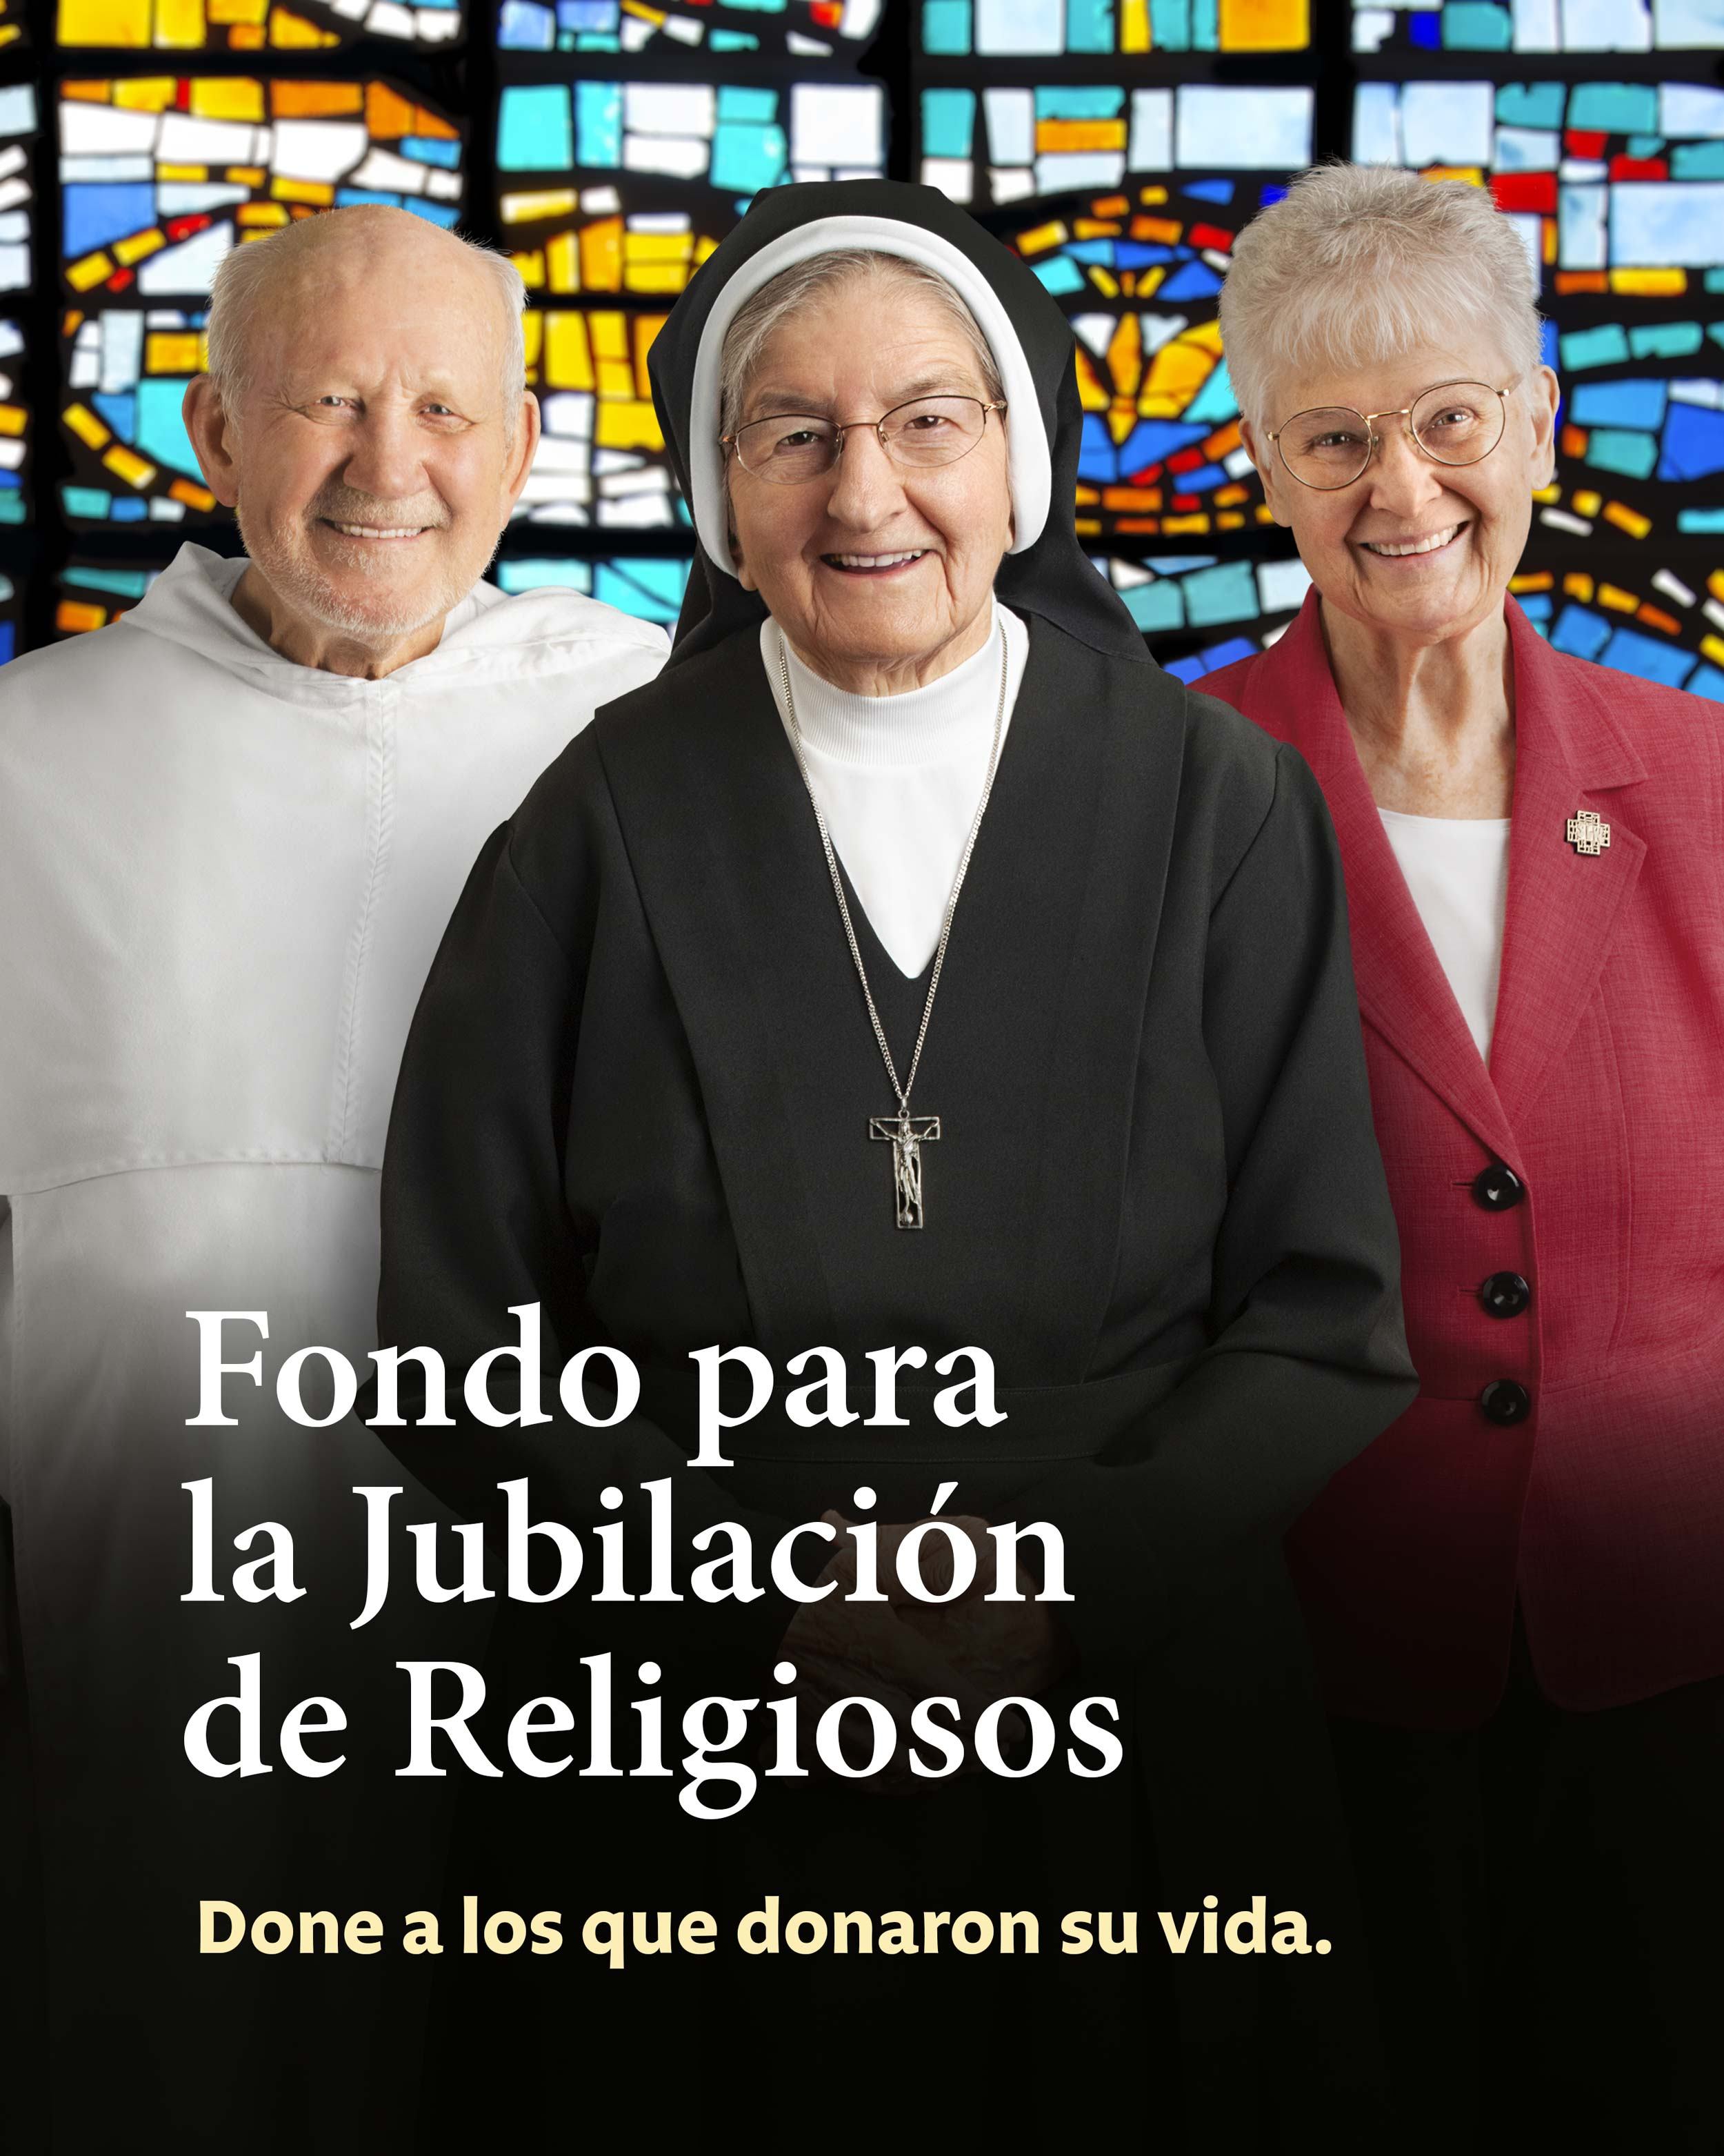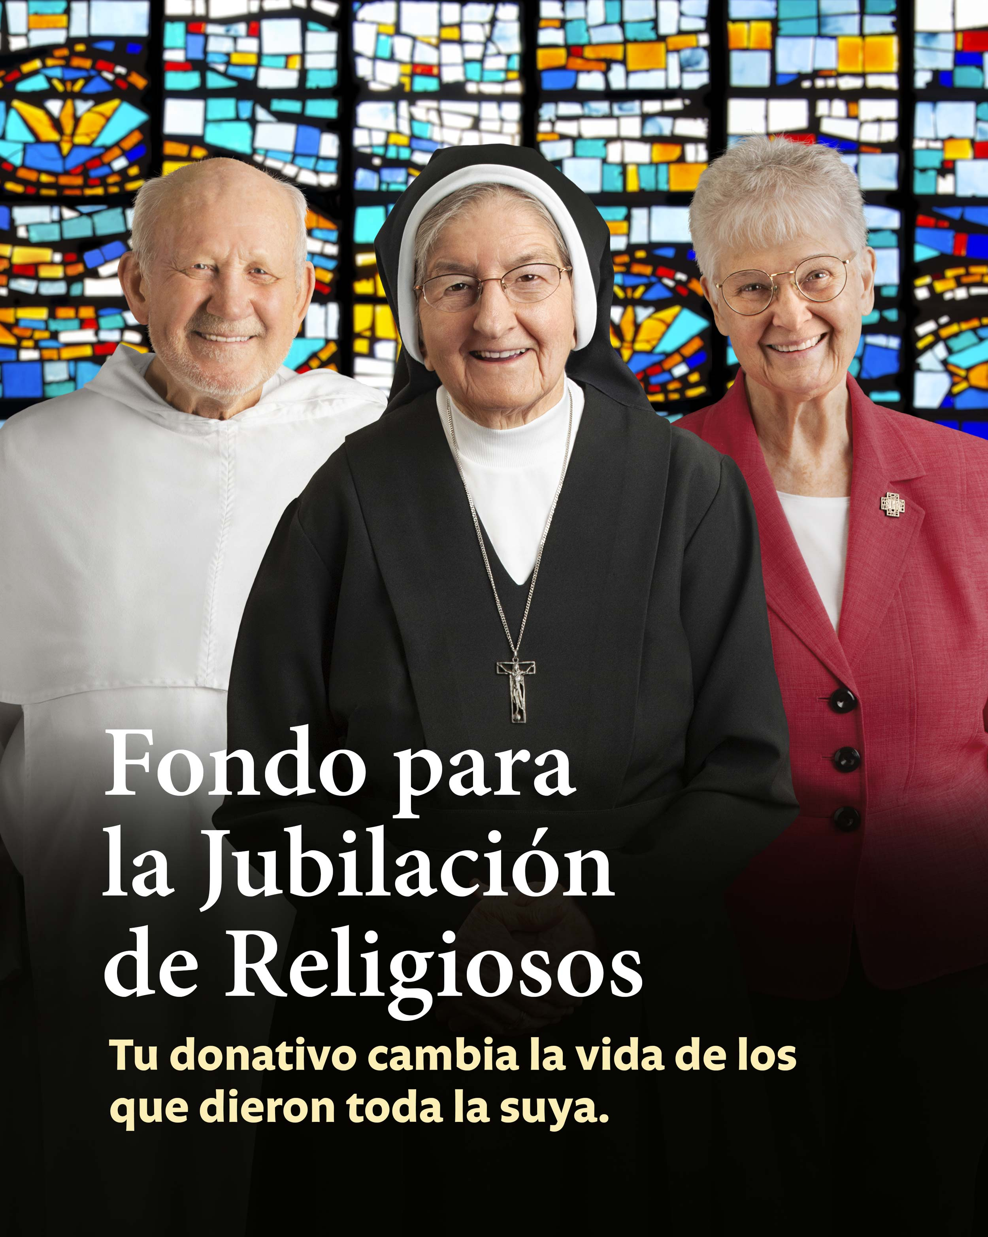
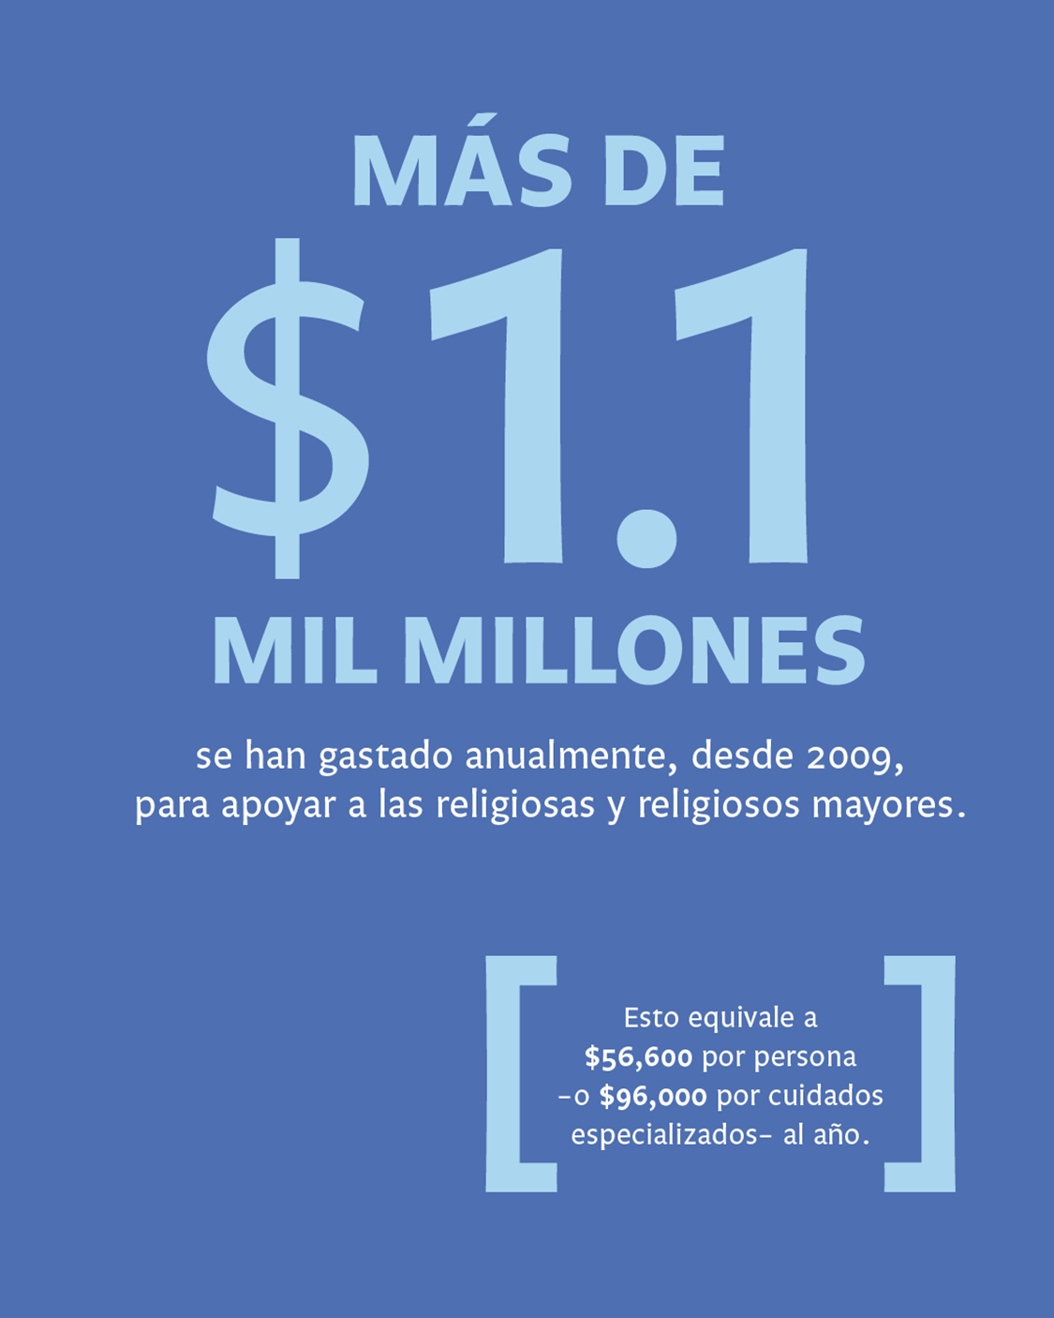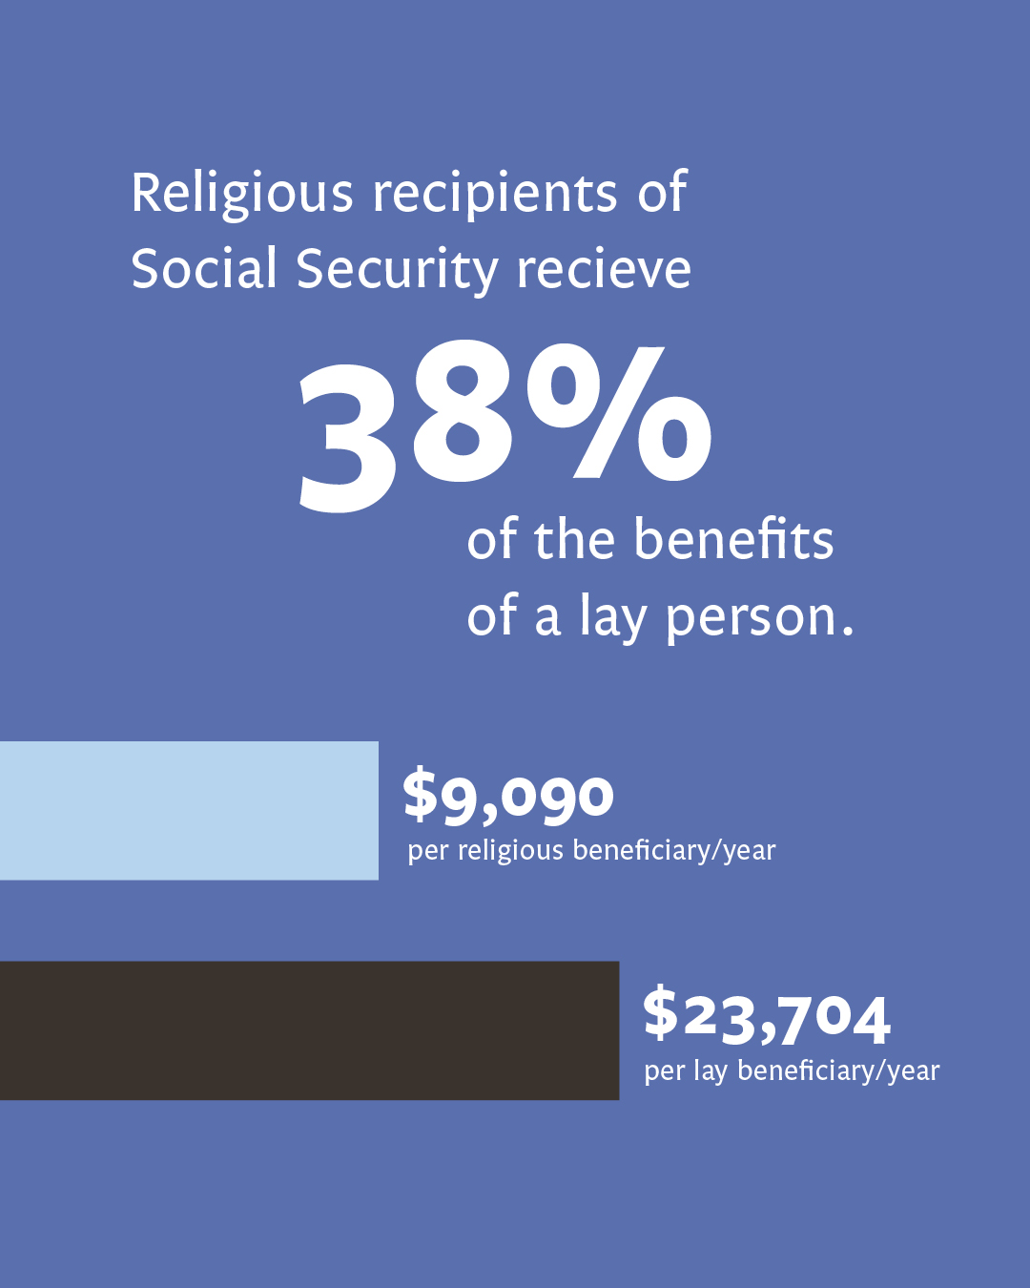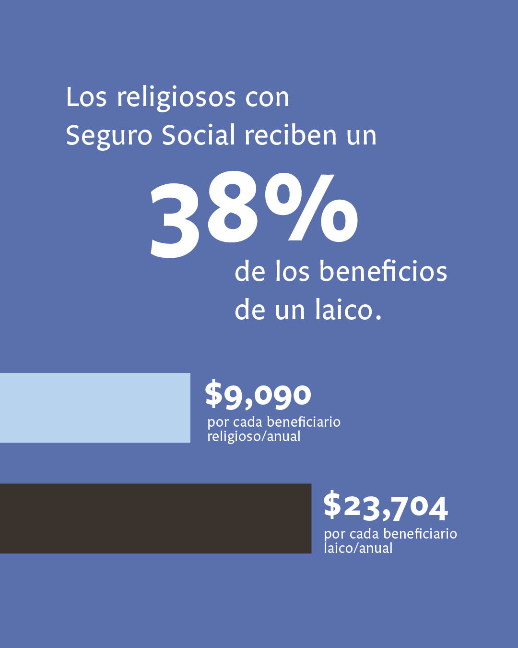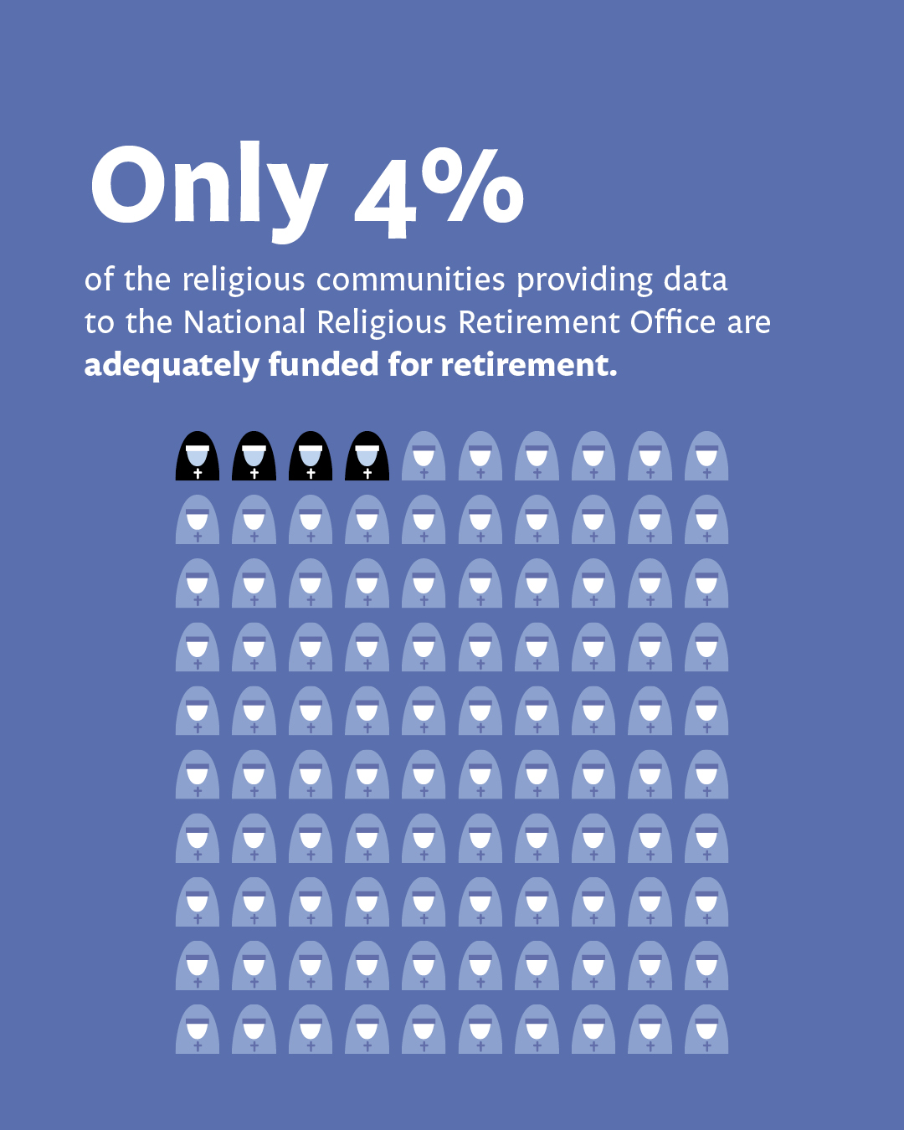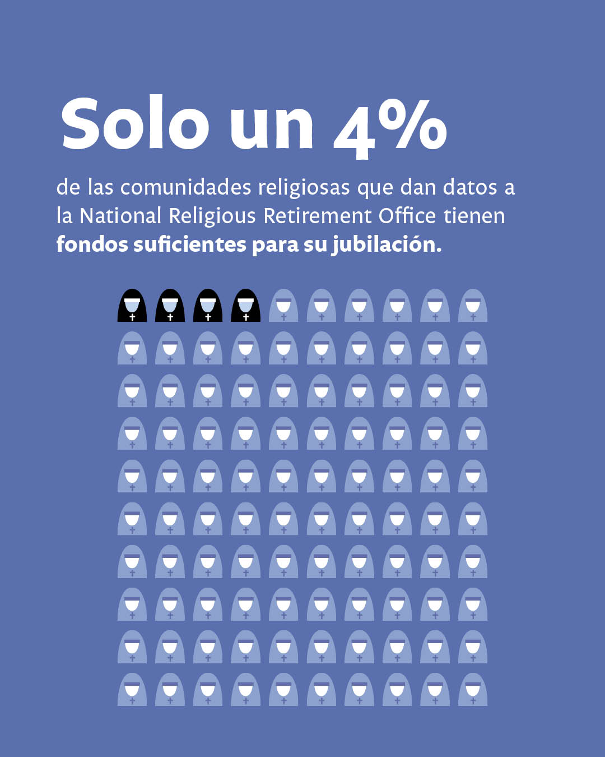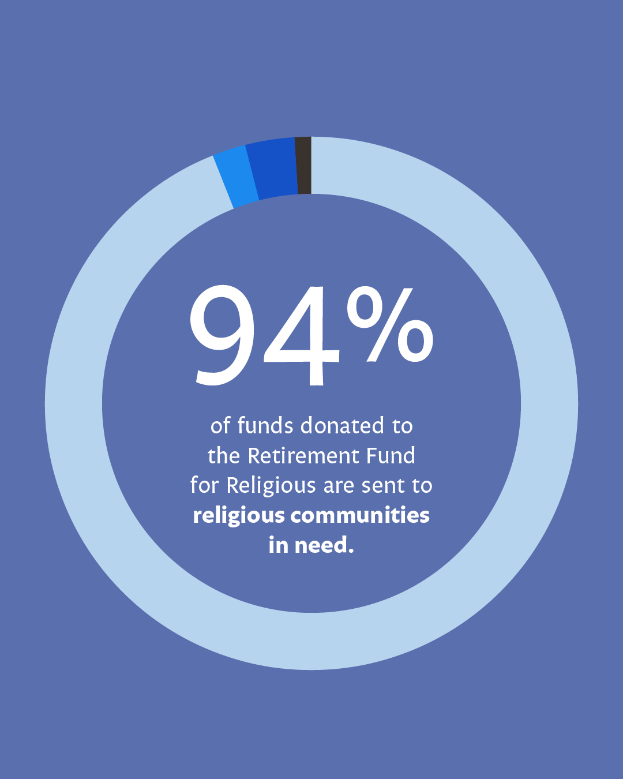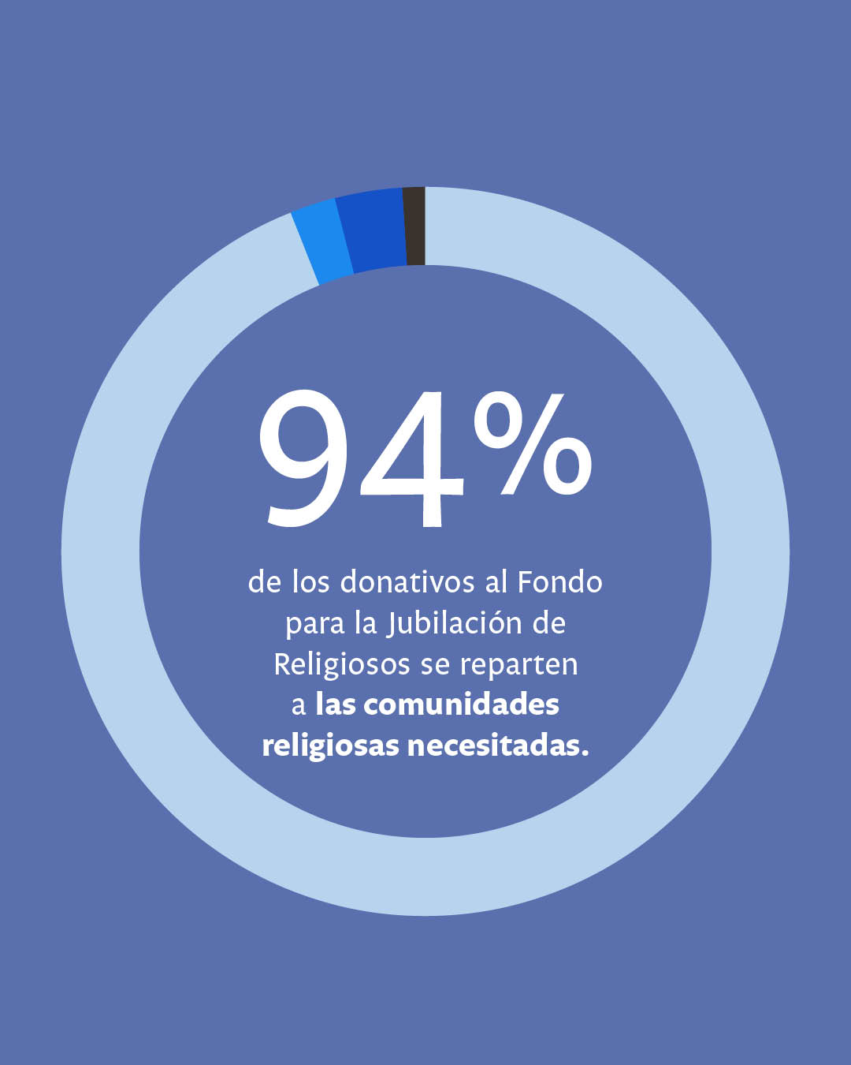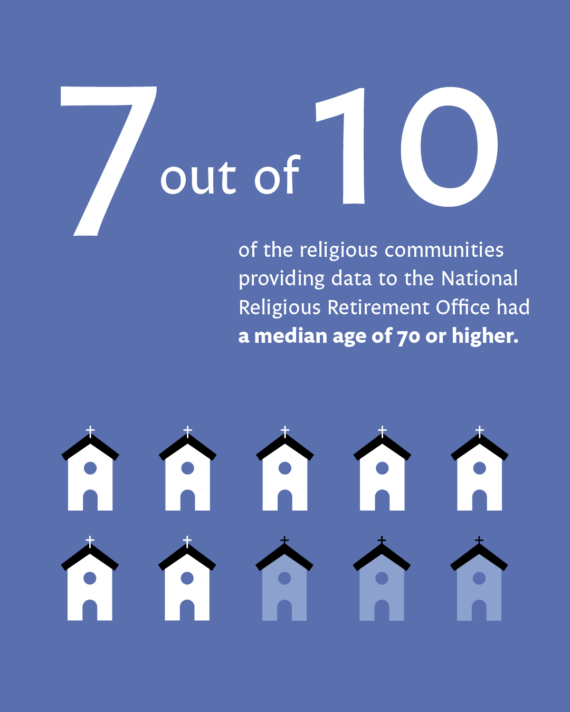 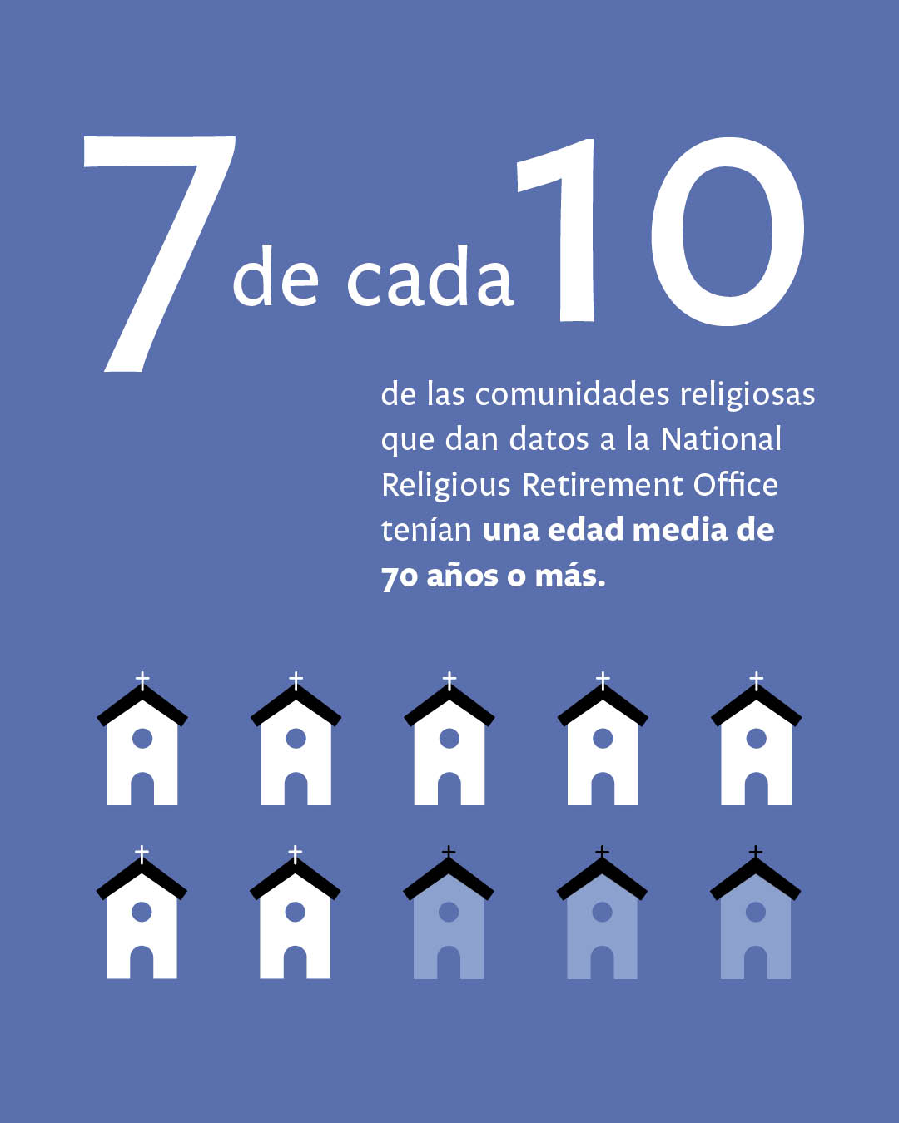 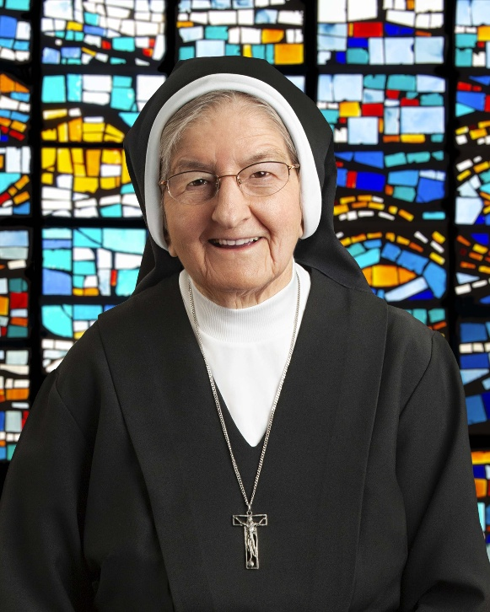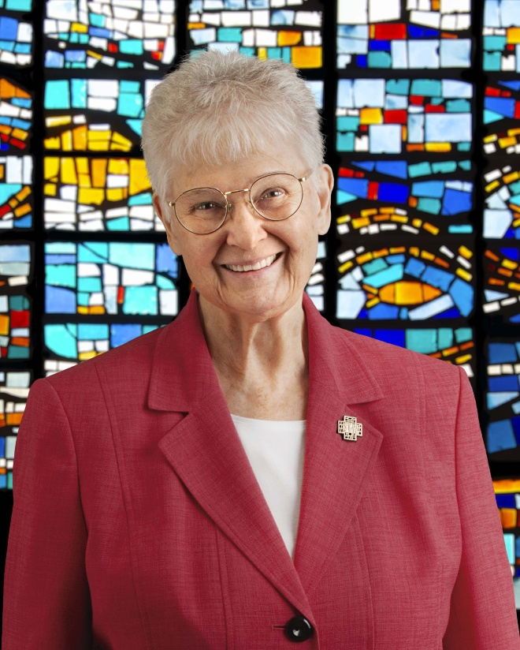 We couldn’t have done this without you! Your gift makes a profound difference in the lives of thousands of grateful senior sisters, brothers, and religious order priests. Thank you for donating to the Retirement Fund for Religious. retiredreligious.org

If you have any questions about this special collection, please contact
Rachel Martinez, CFRE, Director of Annual Giving and Grants of the Advancement Foundation,
at 817-382-4939 or rmartinez@adv-fdn.org

