Pulpit/Bulletin announcements for September
Please remember to update your website with the new Appeal web banners
September 21-22, 2024 Announcement Weekend
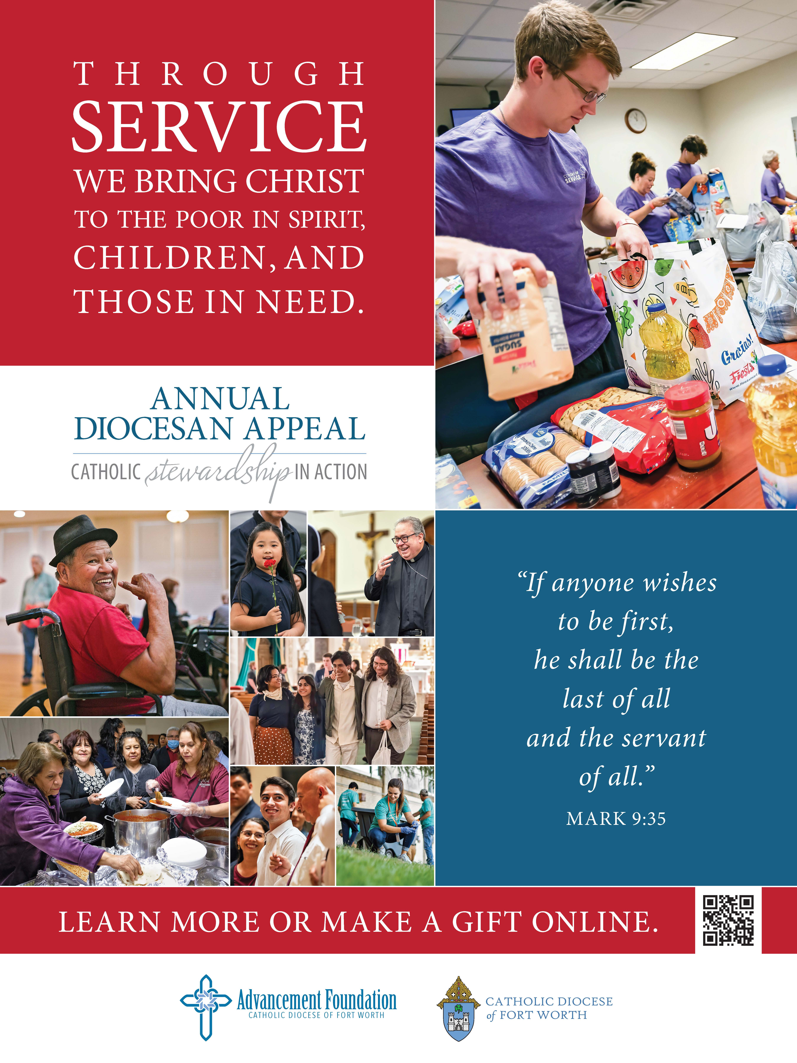
Pulpit announcement:
When you are in a dark place, even the smallest bit of light makes all the difference. Next
weekend the Annual Diocesan Appeal begins, serving thousands of individuals and families in the Diocese of Fort Worth. Through your generosity, you are a great light in the lives of many, helping them to find hope in Christ! Please read Bishop Olson’s letter in the bulletin and discern on your call to service through charity in the diocese.

Intercession:
For our parish community, that renewed in our trust in the Lord who loves us, we might boldly and generously respond to our Annual Diocesan Appeal

Bulletin Text:
After reading Bishop Olson’s letter included in today’s bulletin, learn more about the Annual Diocesan Appeal at www.advancementfoundation.org
Use photo above or any option on the following pages.

September 28-29, 2024 Commitment Weekend
Pulpit Announcement: These past few weekends we learned about the Diocese of Fort Worth’s Annual Diocesan Appeal. I hope you were able to pray about your gift to the diocese and are ready to make a commitment this year. PLEASE FIND A RED AND BLUE BROCHURE IN YOUR PEW.

Please pass extra brochures along so that every family in your pew has one.
Please open the brochure and look for the panel that says “Ways to Give.” There are four ways
to give. Digital giving is preferred to help save the cost of paper and postage. Either scan the
QR code, type in the URL on your phone or text the number to give online.
If you’d prefer to give by check or cash, please fill out this brochure, insert your gift into the
envelope pocket, tear, seal and add a stamp. You are always welcome to call the Foundation
to make a gift over the phone.

As you take a moment to complete this process I will pray the Appeal prayer:
Lord God, We praise you and thank you for your love for every human person. Everything we
are and everything we have is your gift. Fill our minds with truth and our hearts with love so
that we may join together as a Diocese living lives of discipleship with Catholic Stewardship in
Action. United through your Son and by the strength of the Holy Spirit, may we be generous
in our support of the Annual Diocesan Appeal.
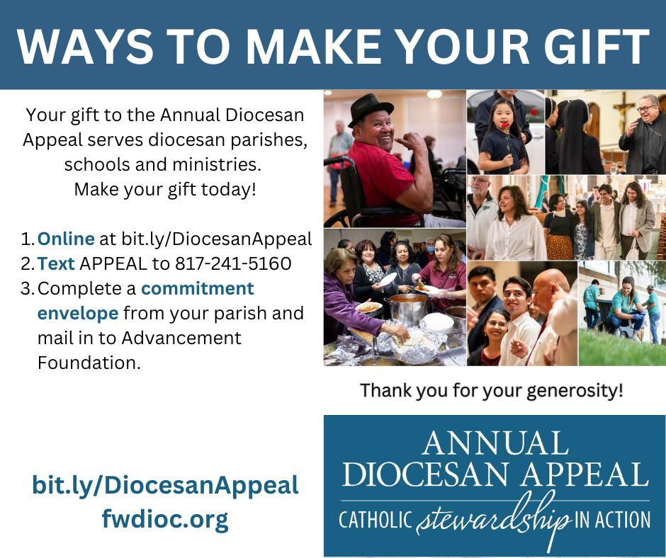
Help us to witness to your grace in our lives by acting in loving response to others.
All this we pray through your Son, our Lord, Jesus Christ.
Amen. Thank you for your generosity.
Intercession: As we have received many blessings from the Lord, large and small, may we find it in our hearts to place ourselves last, helping those in need through the Annual Diocesan Appeal. We pray to the Lord…

Bulletin Ad: Photo with optional caption: Help our parish reach goal! We are one of 92 parishes who can make an impact for the Diocese of Fort Worth ministries, vocations, education and those in need.

October 5-6, 2024 Follow Up Weekend
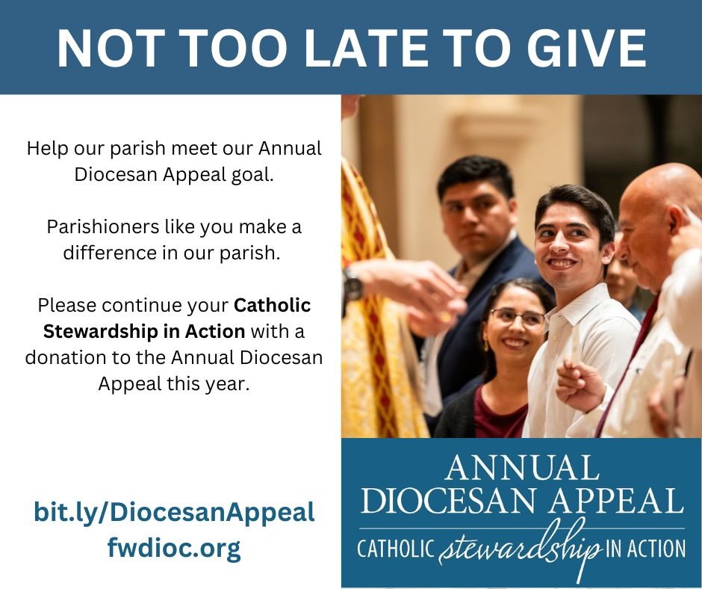
Pulpit Announcement: Thank you to all the PARISH NAME parishioners who have committed to the Annual Diocesan Appeal. For those familiar who have not yet made a donation, it is not too late. You can set up a gift online to begin at a later date. There are commitment envelopes located (in the pews, brochure racks, etc.). Your commitment will help our parish reach 100 percent participation. Thank you for helping us reach goal and answer Jesus’ commandment to love one another as he loved us.
Intercession: That the members of our parish and our broader Diocesan family unite in service to the Lord by participating in the Annual Diocesan Appeal. We pray to the Lord…

Bulletin Text: Photo with optional caption: Thank you to all parishioners who made a gift to the Annual Diocesan Appeal. Any gift, no matter the size, will make a huge impact.

September 14-15 Accountability Weekend
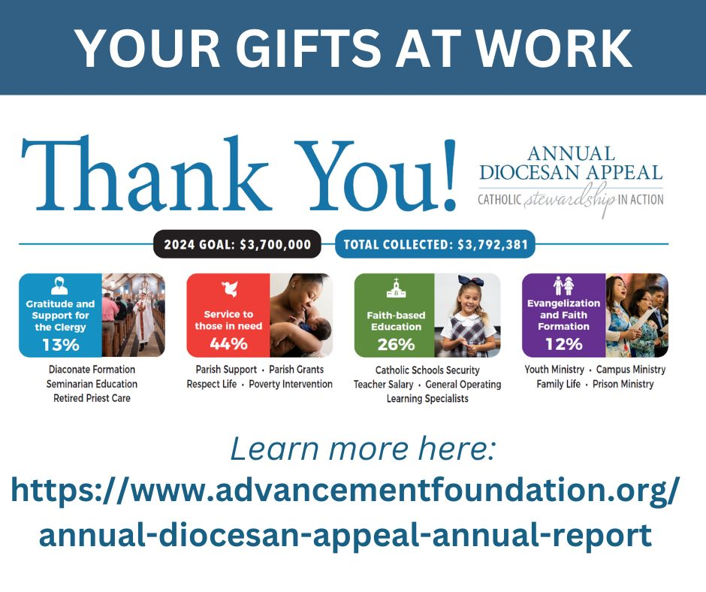
Bulletin ad:
Parish who met goal: Last year our parish met our Annual Diocesan Appeal goal! This was only possible because of the many stewards in our parish who made a commitment to the Annual Diocesan Appeal. Learn more about where the appeal made an impact in the Diocese of Fort Worth.

Parishes who nearly met goal: Last year our parish nearly met our Annual Diocesan Appeal goal! Thanks to parishioners like you who made a commitment. Learn more about where the appeal made an impact in the Diocese of Fort Worth.
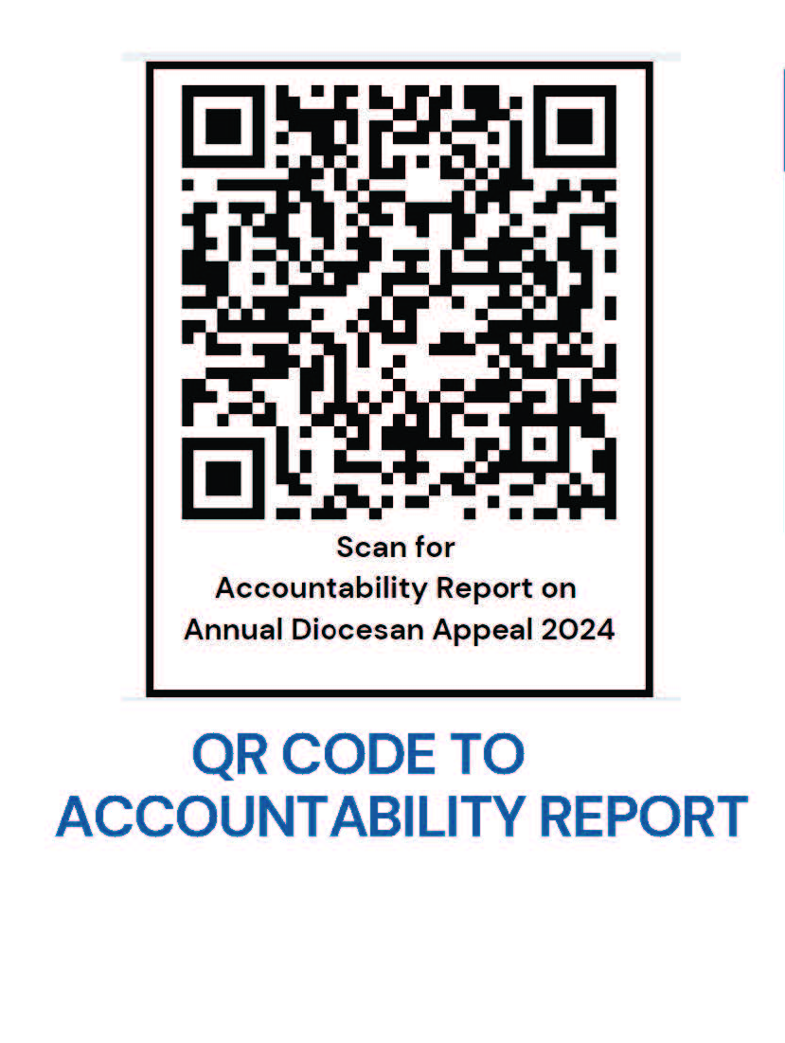
All parishes: Many parishioners from our parish made an impact in the Diocese of Fort Worth through the Annual Diocesan Appeal. Please review the entire 2024 Accountability report online at AdvancementFoundation.org or scan the QR code.
Intercession:
For Diocesan Appeal grant recipients, that they steward the gifts given to them through the charity of our parishioners through the Annual Diocesan Appeal with integrity serving as the hands of Christ throughout the Diocese of Fort Worth.

Bulletin Text: Learn where the Annual Diocesan Appeal donations made an impact last year. Read the accountability report here. Include photos above.

